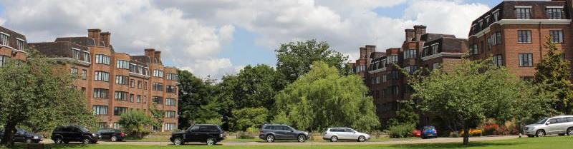

The Manor Fields Estate Limited

Manor Fields Putney Hill London SW15 3NE
Telephone : 020 8788 1017 e-mail: manager@manorfields.co.uk
December 2023

Automated External Defibrillator “AED”

Dear Leaseholders and Residents,

A defibrillator has now been installed on the wall at the rear of the Estate Office.

Although there is no current legal obligation in the UK requiring the provision of an AED on an estate such as Manor Fields, the directors’ have taken the decision that this is a sensible and reasonable facility to have on site for the health and wellbeing of all staff and residents.

Using The Defibrillator

AEDs are compact and easy to use. They can be used by anyone, whether they have had formal training or not.

The AED gives the person using it voice instructions and it will not allow a shock to be given unless the collapsed person needs one. The AED will tell you when to press to shock button.

After the shock has been given, the defibrillator will tell you to continue CPR (Cardiopulmonary Resuscitation) for two minutes before it re-analyses any next steps. If the defibrillator tells you that a further shock is not needed, continue CPR for two minutes before the defibrillator again re-analyses.
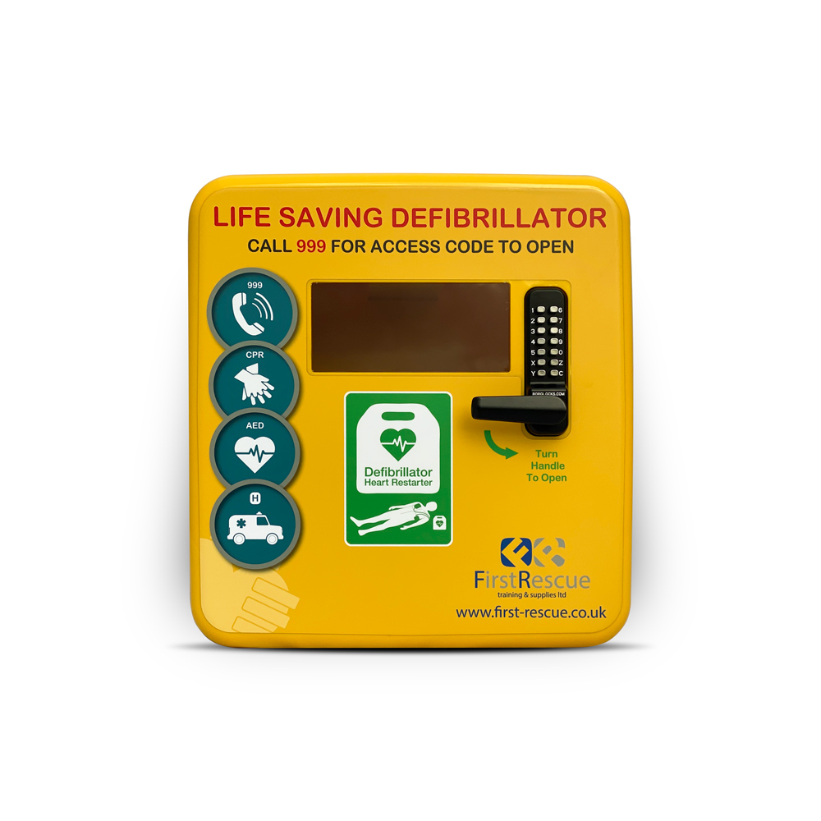
If you find yourself requiring access to the AED, it can be opened by using the Access Code C159X
Yours sincerely


Heather Watterson
Estate Manager

